**Teaching Artist Name:**  **Date:**

**Residency Map**

**Program Manager Section**

*This page will be filled out by the program manager using information provided at the planning meeting*

|  |  |
| --- | --- |
| **Program Manager Name:** |  |
| **District:** |  |
| **School number, borough letter, name:**  **(Ex: PS 130K - Parkside School)** |  |
| **Program Name:**  **(Ex: Broadway Jr, MLL-SWD, CASA )** |  |
| **Teaching Artist name(s):** |  |
| **Art Form/Discipline:** |  |
| **Grade (s):** |  |
| **Number of sessions:** |  |
| **Length of Classes (ex: 45 min):** |  |
| **Number of classes:** |  |
| **Planning Meeting Date:** |  |
| **Number of reflection meetings:** |  |
| **Learning Outcomes & Student Info**   * Classroom Teachers' Goals (Stated at the Planning Meeting): * Student interests, cultural backgrounds, any additional information pertaining to students |  |

**Essential Outcomes**

***(Can be co-generated with teachers and PM during planning meeting or teacher arts workshop)***

|  |
| --- |
| **Goals/Learning Outcomes:** (*Skills and Knowledge in the Arts Discipline)* |

[NYC Blueprints for teaching and learning in the arts](https://www.weteachnyc.org/resources/collection/blueprint-for-teaching-and-learning-in-the-arts/)

(Please Identify 1-2 benchmarks aligning w/residency focus)

|  |
| --- |
| **NYC Blueprint Benchmark(s):** |
| **School Curricular Connections (can be social emotional, overarching school goals, or specific curricular connections):** |

**Big Picture Focus**

**Please consider the** [**Equity Choice Points**](https://teachwithartsconnection.org/llef-equity-choice-points/) **throughout your planning process.**

|  |
| --- |
| *Please provide the focus title for each session.*  **Session 1:**  **Session 2:**  **Session 3:**  **Session 4:**  **Session 5:**  **Session 6:**  **Session 7:**  **Session 8:**  **Session 9:**  **Session 10:**  **Session 11:**  **Session 12:**  **Session 13:**  **Session 14:**  **Session 15:** |

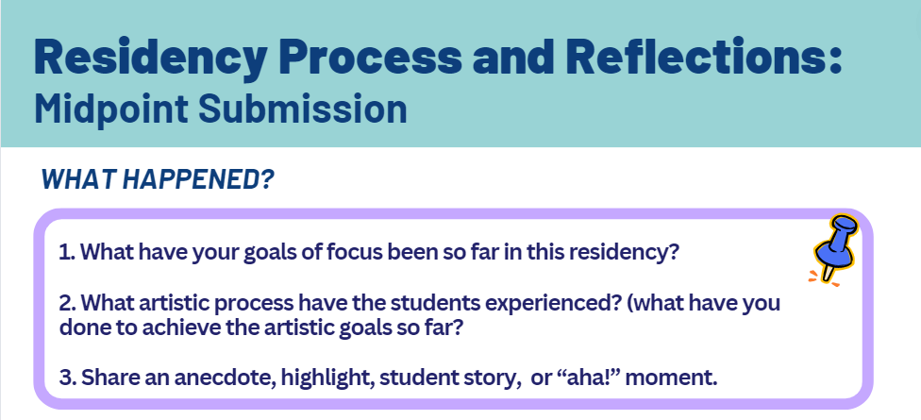

**MID-POINT: SUBMISSION #1**

|  |
| --- |
| ***What Happened?*** *(Please answer questions 1-3)* |

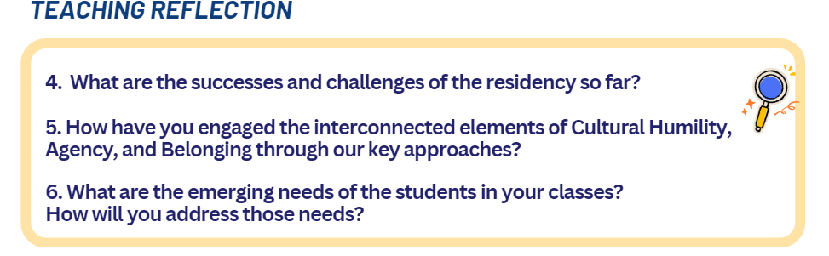

[JLAEF - Overview](https://teachwithartsconnection.org/wp-content/uploads/2024/09/Copy-of-ACs-JLAEF-One-Pager-6.pdf) & [”Equity Choice Points”](https://teachwithartsconnection.org/llef-equity-choice-points/)

|  |
| --- |
| ***Teaching Reflection #1*** *(Please answer questions 4-6)* |

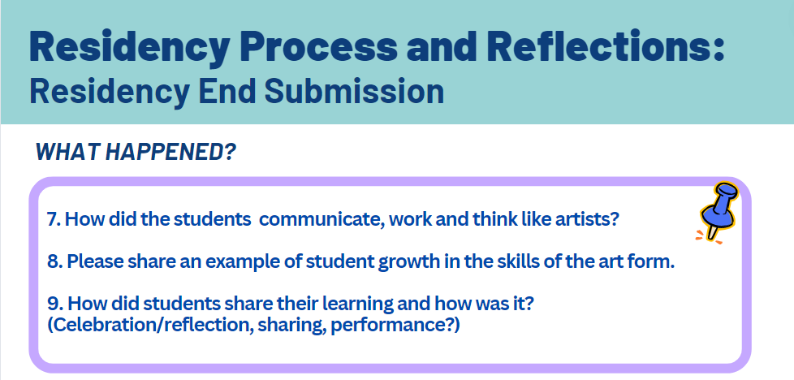

**MID-POINT: SUBMISSION #2**

|  |
| --- |
| ***What Happened?*** *(Please answer questions 7-9)* |

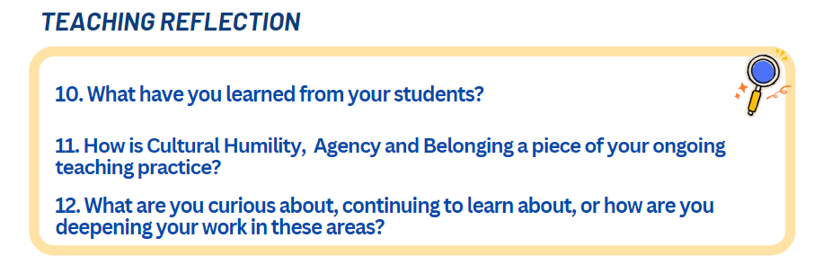

|  |
| --- |
| ***Teaching Reflection #2*** *(Please answer questions 10-12)* |

|  |
| --- |
| ***Miscellaneous Notes and/or Project Pictures:***  ***(OPTIONAL)*** *Planning notes, logistical notes, pictures of student work/process* |

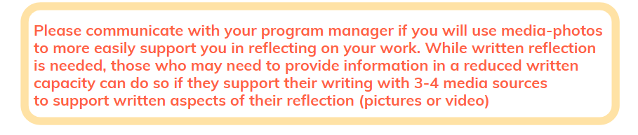

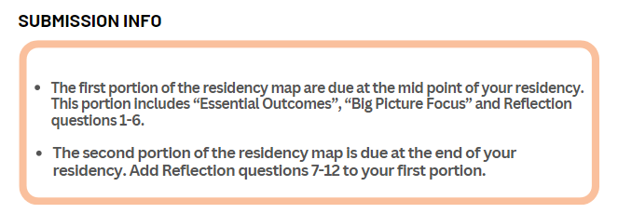

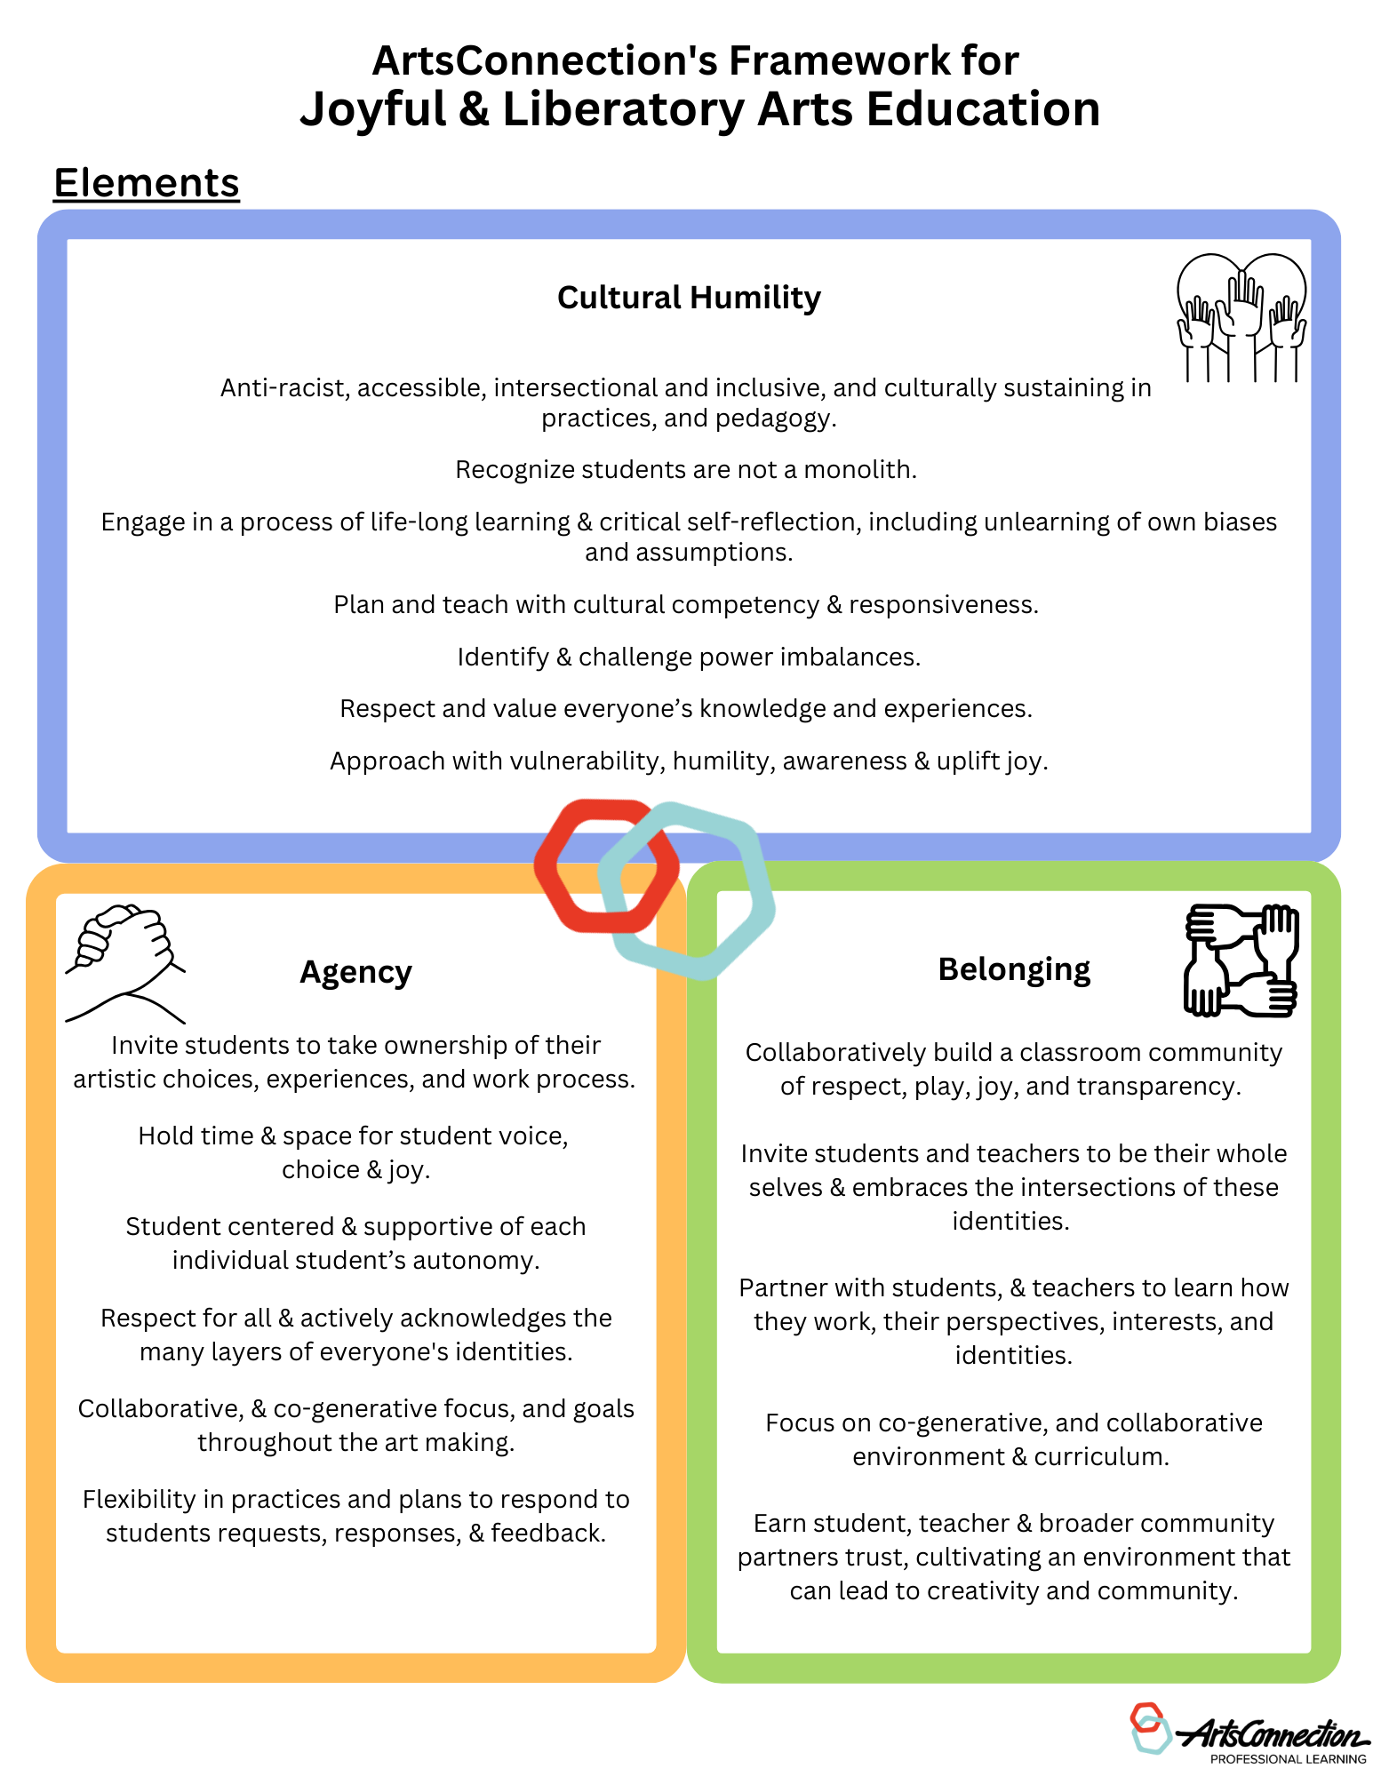

***ArtsConnection's Framework for Joyful & Liberatory Arts Education***

**Key Approaches**

